**Step 1: Disabling zabbix**

User : AD-Authentication

Zabbix

<https://lp-samon01.co.ihc.com/zabbix>

or

CLI

lpv-sapwn01

USername: zabdisable

Password : temp01

sudo su - gabagool

/usr/local/zabbix-scripts/z-delete-host hostname

**Step 2: Taking the pre-check and shutdown the VM**

Pre-check information

* Create mount point “/IMH_Internal_Share”
* Mount  the nfs share ( mount -t nfs lps-nfs01:/IMH_Internal_Share   /IMH_Internal_Share)

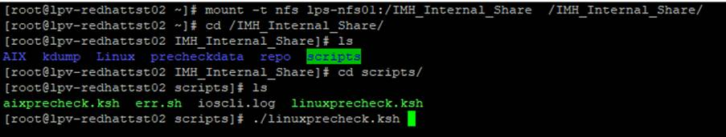

Shutdown for 30 days

**Step 3: Renaming the VM in the Vcenter**

Vcenter :<https://lpv-imhprdvc01.co.ihc.com/>

**Step 4: Creating a task in outlook.(**[**im-linux-ops@dxc.com**](mailto:im-linux-ops@dxc.com)**)**